Correction for background calculation during TADI 2024 campaign and its implication on CH₄ emission rates for reported values by Heidelberg University.
Julia B. Wietzel and Martina Schmidt (Heidelberg University)
Dec 10th 2024

The team from Heidelberg University participated in a one-week controlled blind release campaign from June 24 to 28, 2024, with a mobile measurement setup for ground-based methane emission quantification. The releases were performed on the TADI platform of TotalEnergies in Lacq, France, and organized by Stanford University. The measurements were conducted with a high-precision trace gas analyzer from Licor (LI-7810) and evaluated using a simple Gaussian plume model.
Problem:
During the first analysis and calculation of the CH₄ emission rates, within six weeks after the campaign, the background calculation was performed incorrectly due to an error in the programming code. A constant CH₄ offset of 10 ppb (or 0.01 ppm see line in code) was additionally subtracted from the calculated CH₄ background The background was incorrectly calculated 10 ppb too low and therefore the CH₄ enhancements (peaks) are 10 ppb too high.
Part in code:
bg.baseline <- rfbaseline(x = input_CH4$UTC, y = input_CH4$CH4, NoXP = 500, maxit = c(15,0),
DOT = TRUE, Scale=function(x) mad(x, center=0))
input_CH4$bg <- bg.baseline$fit -0.01 # offset parameter

This effects especially the smaller CH₄ concentrations and therefore the lower CH₄ release rates as higher CH₄ enhancements were calculated due to the wrong background calculation. An example of a time series is shown in Figure 1 a (Release 1 June 24th) with the background fit including the offset error in red and the corrected background fit in blue.
The background was corrected for all release experiments with release rates < 2 kgCH₄ h⁻¹ (35% of all releases) as for higher release rates no significant change is expected. A graphical representation of the determined emission rates for the affected range and a table with the corresponding values are shown in Figure 1b and Table1.
For the controlled CH₄ release experiments with release rates between 0.5 and 2.0 kgCH₄ h⁻¹ the release rates calculated and reported by Heidelberg University were estimated 10-30% to high due to the calculation error in the background of the CH₄ concentration.

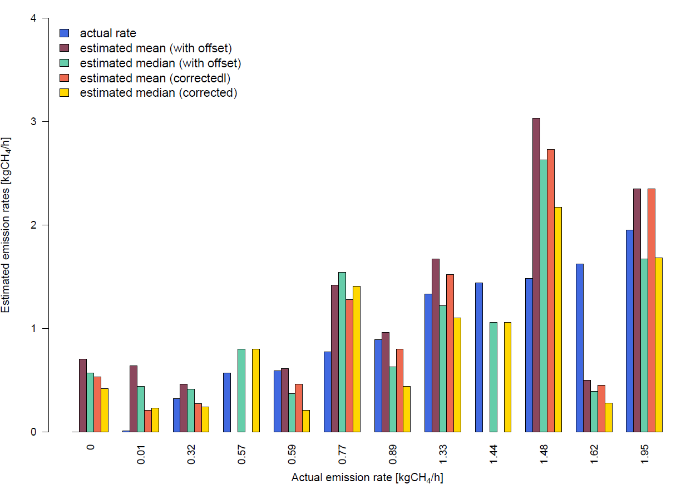
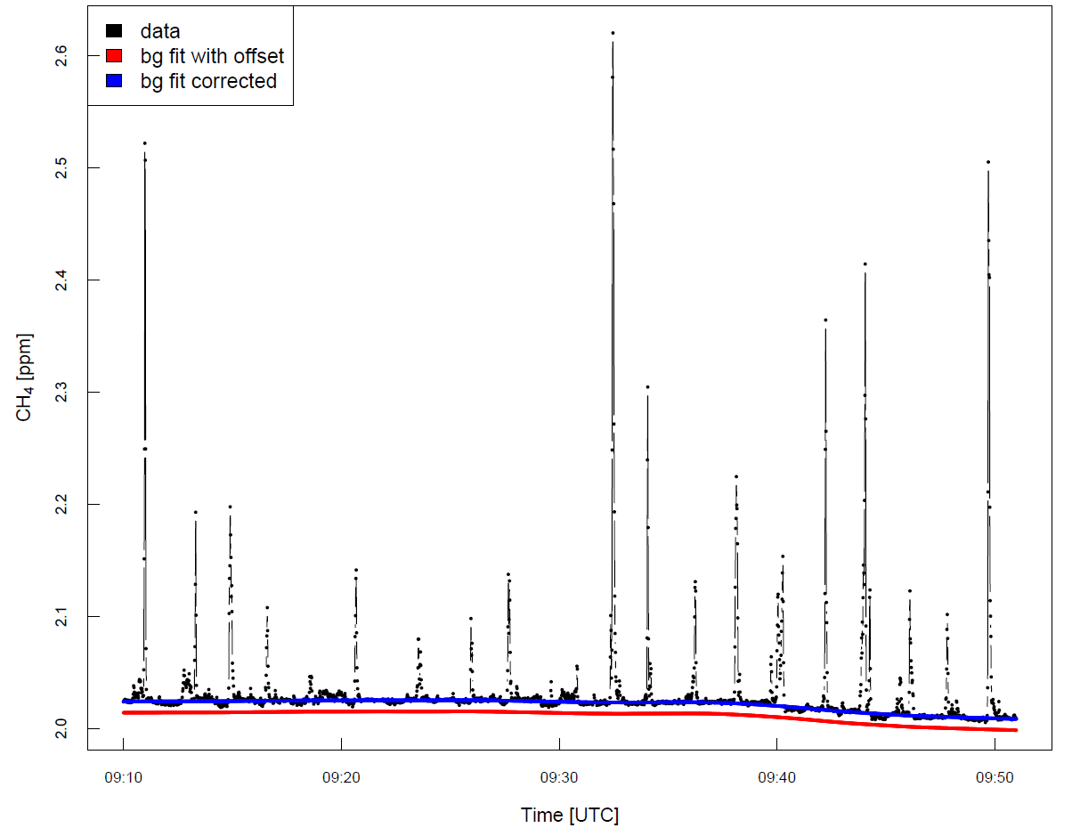
a b
Figure 1 a Time series of the measured CH₄ concentration during plume crossings for a 45 minute release on June 24th (RE1_1). The background fit affected by the offset error is marked in red and the corrected background fit in blue. b Graphical representation of the change in the affected releases. Bar plot showing the estimated CH₄ emission rates with the error in the background calculation and with the corrected background (each as mean and median) compared to the true release rate in blue.

Release No. | Date | Release rate [kg/h] | Estimated Mean [kg/h]  uncorrected | Standard error [kg/h]  uncorrected | Estimated Median [kg/h]  uncorrected | Standard error (median) [kg/h]  uncorrected | Estimated Mean [kg/h]  corrected | Standard error [kg/h]  corrected | Estimated Median [kg/h]  corrected | Standard error (median) [kg/h]  corrected
RE_3_8 | 2024-06-26 | 0.00 | 0.70 | 0.14 | 0.57 | 0.16 | 0.53 | 0.13 | 0.42 | 0.15
RE_3_5 | 2024-06-26 | 0.01 | 0.64 | 0.18 | 0.44 | 0.06 | 0.21 | 0.03 | 0.23 | 0.06
RE_5_2 | 2024-06-28 | 0.32 | 0.46 | 0.06 | 0.41 | 0.03 | 0.27 | 0.05 | 0.24 | 0.03
RE_4_3 | 2024-06-27 | 0.57 |  |  | 0.80 | 0.26 |  |  | 0.80 | 0.26
RE_1_1 | 2024-06-24 | 0.59 | 0.61 | 0.10 | 0.37 | 0.09 | 0.46 | 0.09 | 0.21 | 0.06
RE_2_1 | 2024-06-25 | 0.77 | 1.42 | 0.18 | 1.54 | 0.24 | 1.28 | 0.18 | 1.41 | 0.23
RE_1_4 | 2024-06-24 | 0.89 | 0.96 | 0.24 | 0.63 | 0.10 | 0.80 | 0.23 | 0.44 | 0.08
RE_3_2 | 2024-06-26 | 1.33 | 1.67 | 0.45 | 1.22 | 0.32 | 1.52 | 0.43 | 1.10 | 0.31
RE_4_8 | 2024-06-27 | 1.44 |  |  | 1.06 | 0.27 |  |  | 1.06 | 0.27
RE_2_8 | 2024-06-25 | 1.48 | 3.03 | 0.46 | 2.63 | 0.43 | 2.73 | 1.43 | 2.17 | 1.15
RE_3_1 | 2024-06-26 | 1.62 | 0.50 | 0.18 | 0.39 | 0.19 | 0.45 | 0.17 | 0.28 | 0.14
RE_2_2 | 2024-06-25 | 1.95 | 2.35 | 0.69 | 1.67 | 0.73 | 2.35 | 0.69 | 1.68 | 0.74

Table 1 Overview of the estimated methane emission rates [kgCH₄ h⁻¹] of all releases below 2 kgCH₄ h⁻¹. The yellow lines are not affected as this was a different measurement method (OTM33-a) with a different type of background calculation. The releases marked red are reported as uncertain, caused by low wind speeds (< 2 m s⁻¹) during the measurements.

